EEZ project – Settings

A newly created EEZ project contains only the basic items in the Settings tab as shown on Fig. 1. organized into General and Build sections.

The General sections is used to define SCPI documentation folder path that will be using during SCPI help HTML files import and update. Please be sure that newly created project is saved first, before this option is used. The recommended path to the SCPI help HTML files is doc subfolder in the folder where project file has been saved.
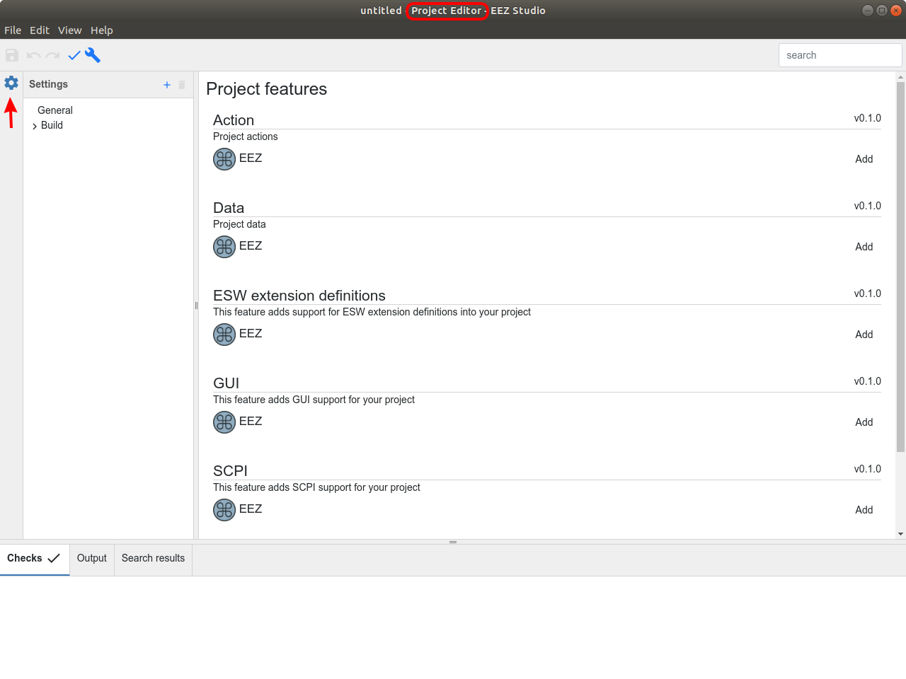Fig. 1: Settings tab for the newly created project
Additionally, we can found here all ESP's currently available Project features. For making an IEXT the following three items have to be added:
- ESW extension definitions
- SCPI and
- Shortcuts
Each of the above mentioned items will add its own tab that follows the Settings tab icon as shown on the Fig. 2.

The Build section contains Destination folder path where IEXTs will be created. The project file folder is defined by default (hence single dot) as shown on Fig. 3.
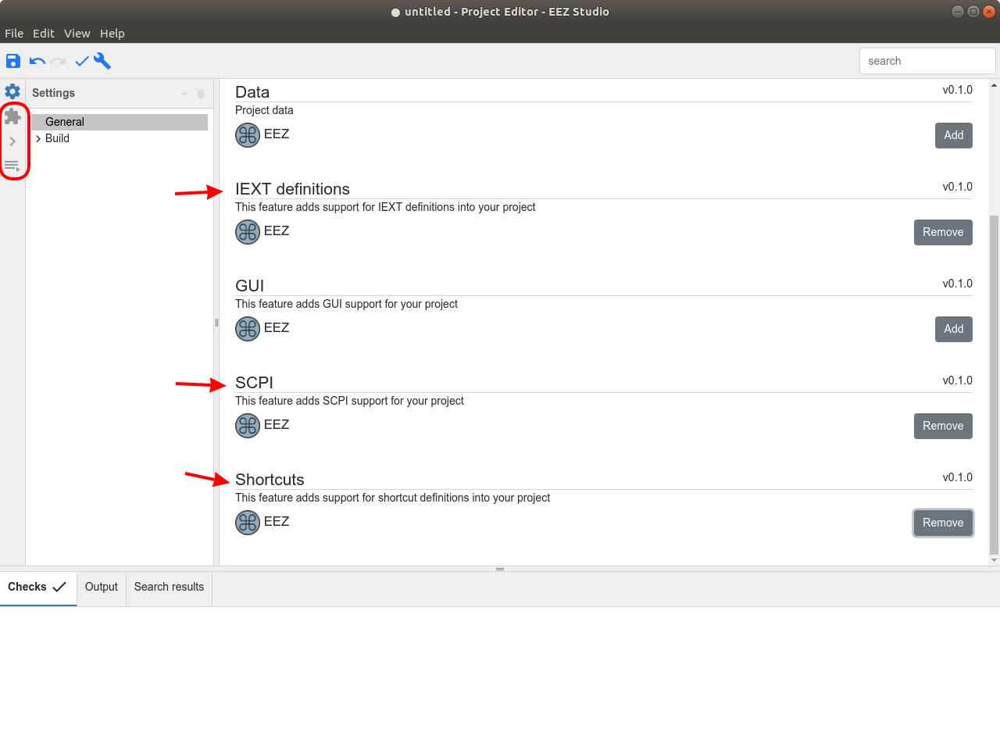Fig. 2: Additional tabs for selected Project features

The Build sections also contains Configurations and Files subsections while Files is still not used for building an IEXT. Configurations sections for a newly created project include only Default configuration which can be renamed if necessary. The Configurations is used to define parameters that are shared between more instruments within the same family, for example, the rigol_ds_mso_1000 IEXT includes four configurations as shown on Fig. 4.
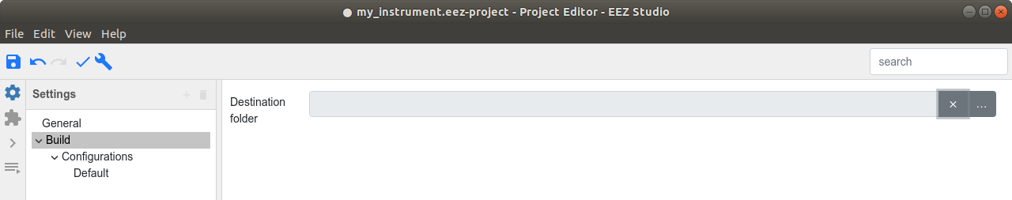Fig. 3: Build destination folder

The Configuration items are as follows:
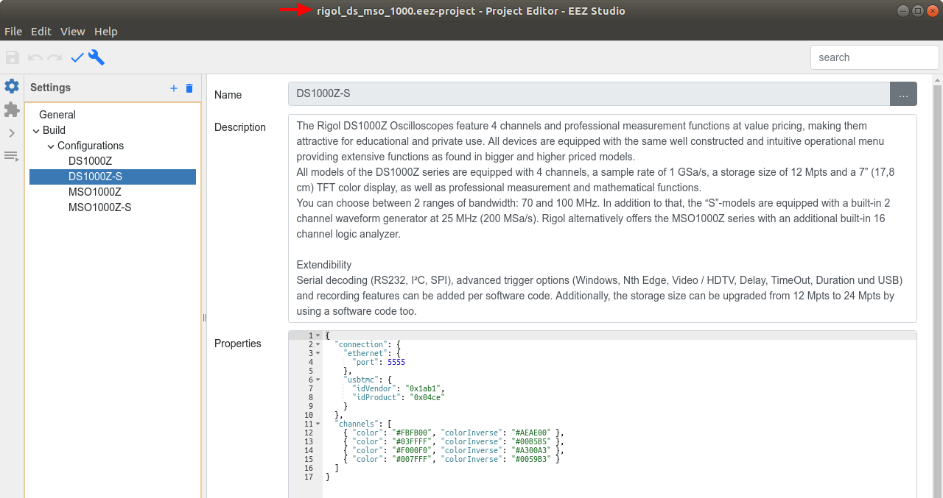Fig. 4: Multiple Build configurations example

Parameter | Explanation
Name | Configuration name that describe e.g. instrument family, or group of instrument models with the same feature within the same family.  For example, the same Rigol DS1000 series instruments exists in two variants with signal generator installed (-S model) or without signal generator. Consequently, model with additional feature comes with more SCPI commands. Creating two configurations gives us possibility to select what SCPI command set is supporting in one or another model even if SCPI commands are located in the same SCPI help file (chapter). The process of how to assign SCPI command help to one or more instruments will be described later in Project file Subsystems chapter.
Description | Additional information about the configuration, e.g. manufacturers promotional text of the instrument family.
Properties | Various Instrument configuration parameters. If defined they will override default ESW values.

There is no limitation in number of Build Configurations, and at least one has to be defined. Configuration adding and removing can be accomplished using options shown on the Fig. 5.

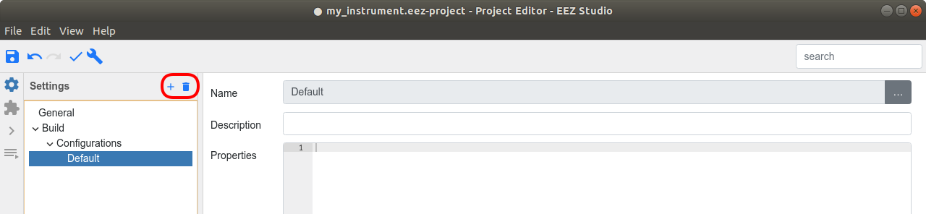Fig. 5: Build configuration Add and Remove options

